Set 2: Elective 2: Russia and the Soviet Union 1914–1945
Source 1A

Source 1B
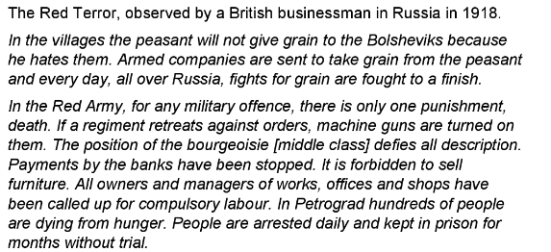

Source 2
(Poster published in 1918 celebrating the one-year anniversary of the Bolshevik Revolution.)
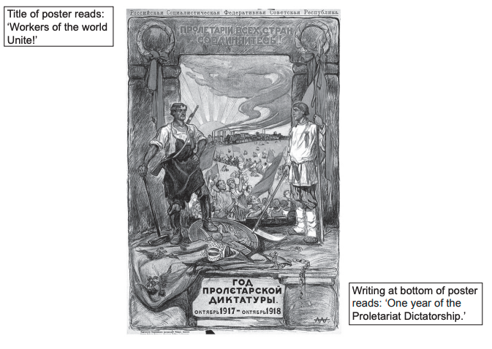

Source 3
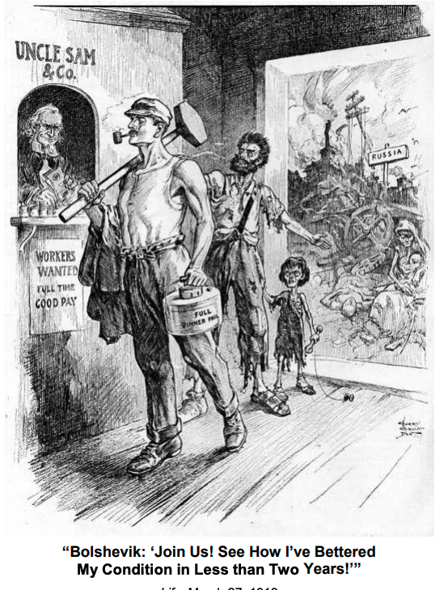

Source 4
(Extract on ‘Bolshevik Consolidation,’ from Key Features of Modern History, a textbook published in 2003.)

By 1924 the Communist Party had survived severe challenges to its authority and consolidated its position in government. Although the use of terror against opponents had become an important method for retaining power, other factors were equally important. Peace had been secured as promised, the land had been redistributed, and the popularity of these measures should not be underestimated. The promotion of factory workers, the basis of the Bolshevik support, into public office had strengthened the Soviet state. The hardships of the years 1918–21 had conversely helped to secure the communists in power. Hunger, unemployment and the flight from towns cut back the potential for resistance.

Above all, there was the leadership of Lenin. Taking the longer view of the need for the revolution to survive, he was willing to compromise in the short term, often in the face of criticism. Hence, the terms of Brest-Litovsk and the NEP [New Economic Policy] were acceptable to him, not because they were in any sense fair or proper, but because they headed off the threats to the revolution posed in the one instance by the German army and in the other by a rebellious populace.

Set 5: Elective 2: Australia’s engagement with Asia
Source 1
(Photograph depicting the clash of supporters and protestors during the visit to Australia of US President Lyndon Baines Johnson in October 1966.)
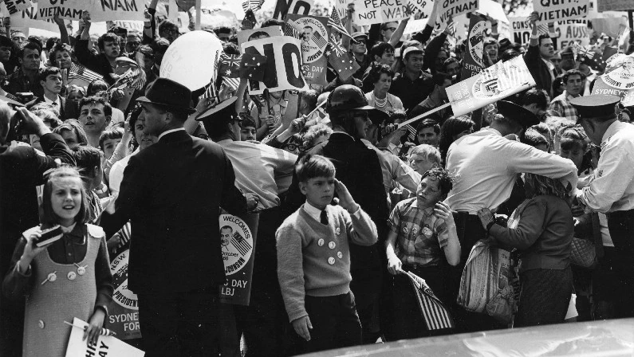

Source 2
(Extract from a speech by Australian Prime Minister Harold Holt during the federal election campaign in 1966.)

Later I shall have more to say about what is happening in South-East Asia and South Vietnam, but the support we and others are giving in South Vietnam is not only helping the people of South Vietnam to resist communist subversion and aggression. It is providing a shield behind which a new Asia can emerge and grow stronger. The presence of ourselves and other friendly forces … is not a commitment to war; it is a commitment to peace and freedom … Together we shall be helping to give the people in these countries the food, the skills, the education and the strength to lead their nations to a better way of life.

That is the kind of involvement we look to with Asia. We all want peace and a peaceful solution of problems and conflicts. We can even be on friendly terms with countries that have fundamentally different ideologies to our own, so long as they don’t try to impose their ideas on us by force, by subversion or any other means

Source 3
(Cartoon by Geoff Hook commenting on the arrival of the first waves of Vietnamese boat people to Australia, published in 1977.)
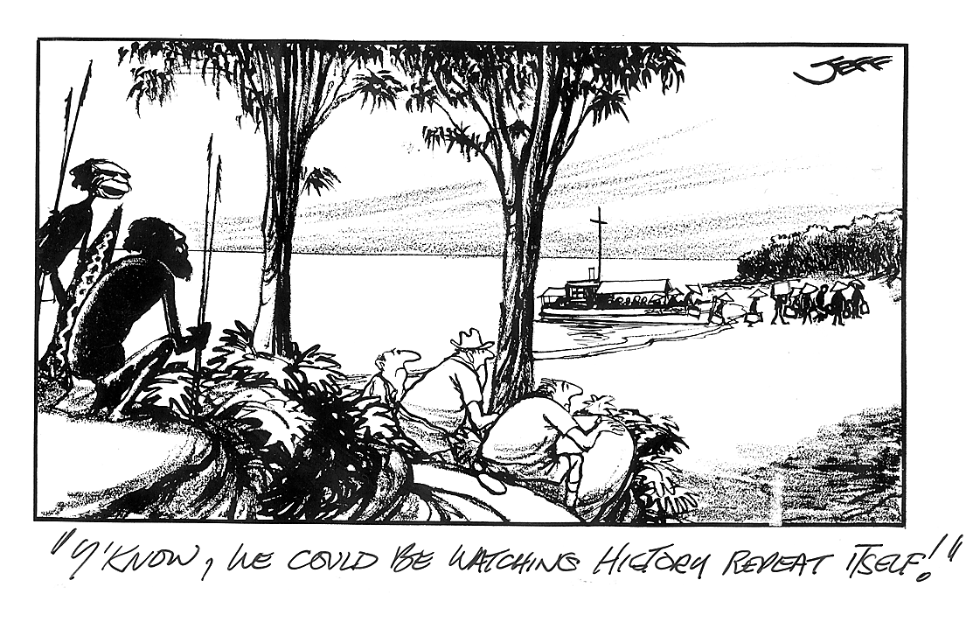

Source 4

